Contents

I. Terms and reference 2

II. Revert local Test Central to earlier version 2

*1.* *Rollback all Test Central servers to the specific version* 2

*2.* *Roll back independent Test Central* 3

*3.* *Rollback using tag* 4

*4.* *Re-bundle Test Central* 6

*5.* *Downgrade/Re-install 3rd party tools* 6

*6.* *Re-start Test Central and verify TC version* 6

*III.* *Re-update Test Central* 7

# Terms and reference

Before following steps on this guide, please understand some terms:

* Test Central servers: you can refer to the **/rails deployment/Rails Application Deployment.docx**
* Rake tasks: standard tasks, custom tasks
* Git commands
* SourceTree application: <https://www.sourcetreeapp.com/>

# Revert local Test Central to earlier version

If you want to revert local Test Central to specific version, we recommend you do it on a new cloned folder to keep your working.

## *Rollback all Test Central servers to the specific version*

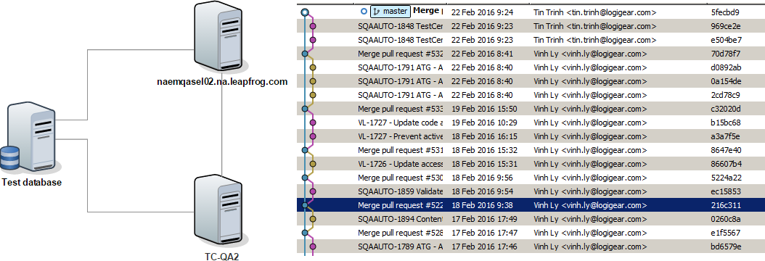

If we have multiple Test Central servers (1 server and other stations), we need to revert all code of Test Central servers to the specific version as below flow:

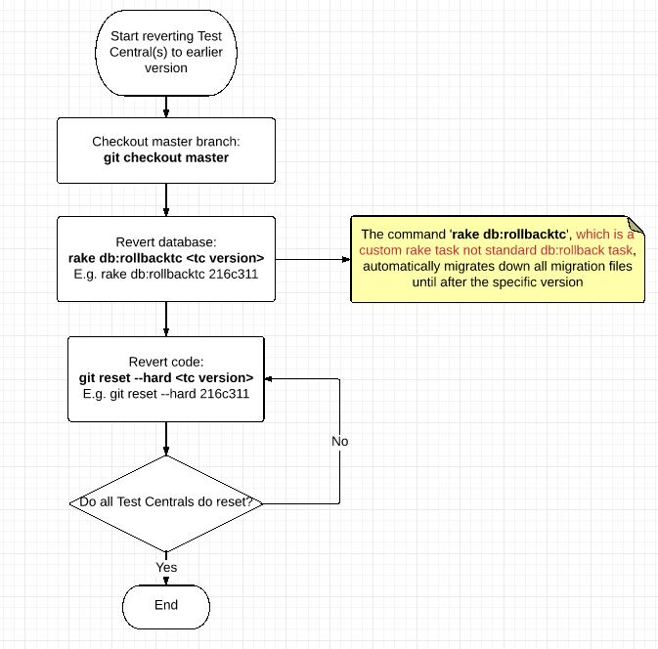

## *Roll back independent Test Central*

This method will wipe out all data; it means we have new Test Central

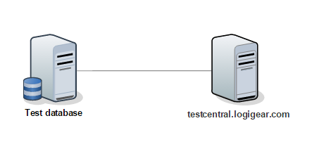

* ‘git reset --hard <commit_id>`
* `rake db:reset`

## *Rollback using tag*

If you want to rollback Test Central using tag, please do the following instruction:

* Point out commit id: you can use SoureTree to do that, like this

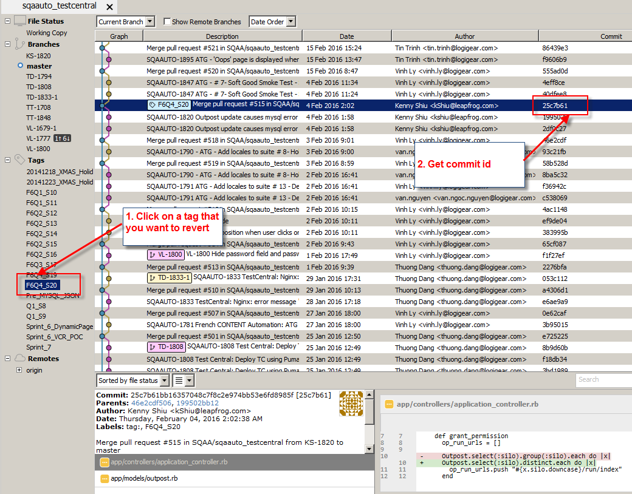

* Run rake task

***rake db:rollbacktc [commit id]***

E.g. rake db:rollbacktc a6df1a5

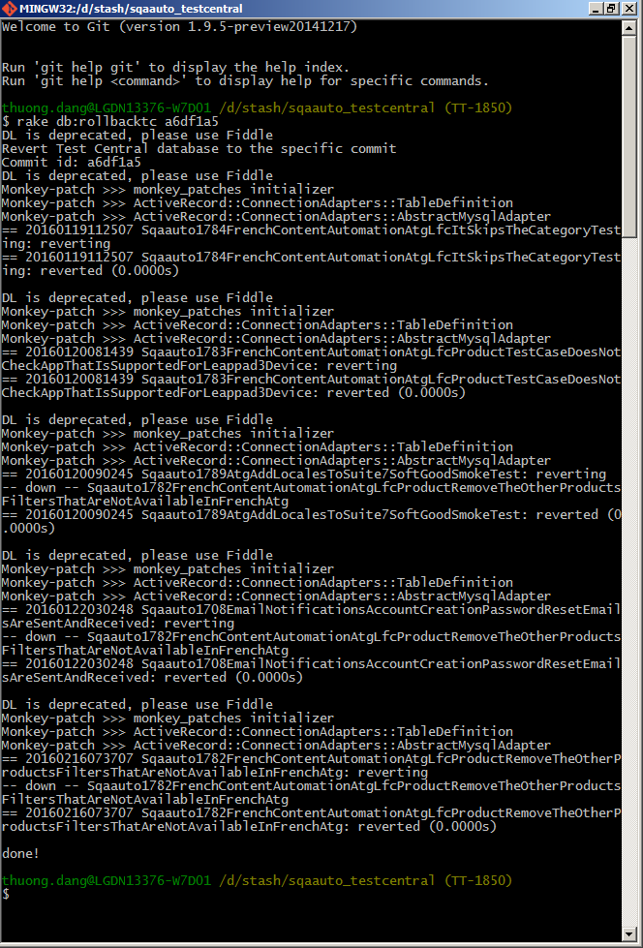

## *Re-bundle Test Central*

After reverting Test Central code, please make sure to re-bundle all Gems lib with following steps

* Delete Gemfile.lock
* Run command: ***bundle***

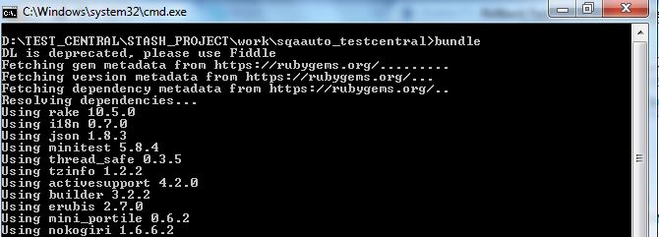

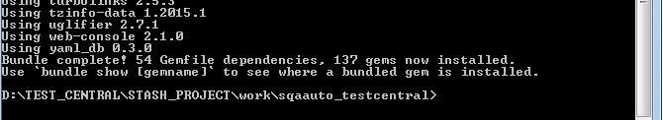

## *Downgrade/Re-install 3rd party tools*

Make sure the version of 3th party tools are mapped with current Test Central version. Review the ‘Rails Application Deployment’ and downgrade/install the appropriate version on 3th party tools

## *Re-start Test Central and verify TC version*

Make sure to re-start Test Central after completing the rollback and to try checking the bottom of the dashboard to verify their version.

# *Re-update Test Central*

The following steps are to re-update Test Central code to latest version

